**SEABIRD ECOLOGY ON DIEGO GARCIA**

**January / February 2018 research trip report**

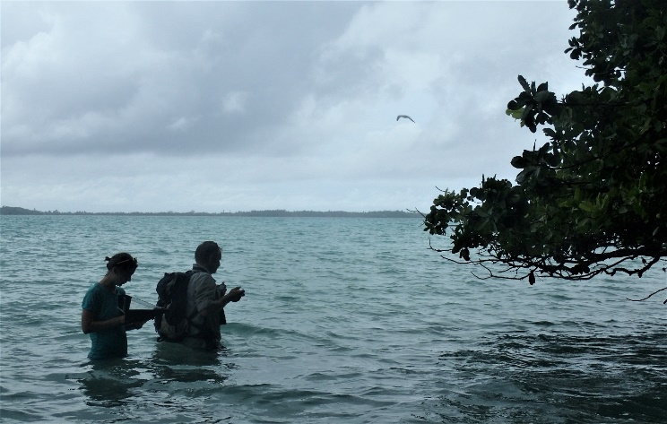

**Figue 1** Censusing the Red-footed Booby colony

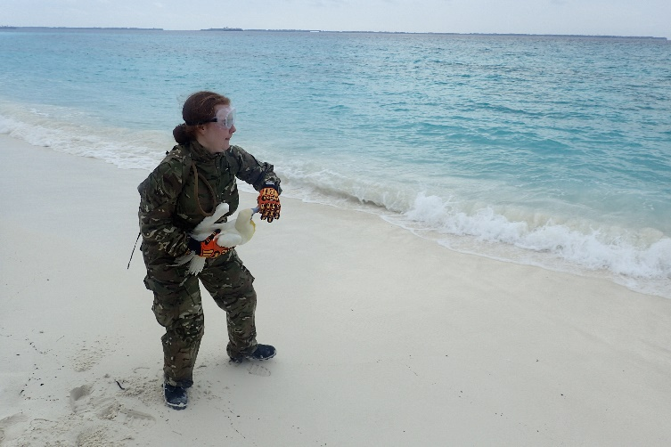

**Figure 2** A volunteer releasing a tagged Red-footed Booby

**Peter Carr & Hannah Wood**

*Institute of Zoology*

*Zoological Society of London*

*Regent's Park*

*London NW1 4RY.*

*Email:* [*peter.carr@ioz.ac.uk*](mailto:peter.carr@ioz.ac.uk)



**Introduction:**. The Zoological Society of London (ZSL) and Exeter University, supported by the Bertarelli Foundation, visited BIOT to undertake research to assess the importance of the BIOT MPA for seabirds. Tracking research was conducted on Diego Garcia (DG) in the Barton and Cust Point area. As in the previous two fieldwork sessions birds were fitted with tail-mounted GPS loggers (IGotU GT-120, Mobile Action Technology Inc.) and leg mounted geolocator (GLS) tracking devices (Intigeo Geolocators, Migrate Technology) to track their at-sea foraging behaviour. In addition a Citizen’s Science Project counting breeding Red-footed Booby took place on the eastern arm of DG, ocean and lagoon-side and on the three islets in the mouth of the lagoon. The research consisted of three objectives and builds on research conducted on DG in 2016:

**Primary Objectives:** (i) To document the year round biology and foraging ecology of breeding Red-footed Boobies (RFB) at Barton Point Nature Reserve, (ii). To document the distribution of non-breeding RFBs from the colony on DG, (iii). To establish the status and distribution of breeding RFB on DG.

Specific to this fieldwork session and in addition to the above, there were three secondary objectives:

**Secondary Objectives:** (i) To collect opportunistic ornithological (and other taxon) records; (ii) To collect data for inclusion in the (international) Indian Ocean Coastal Waterbird Count 2018; (iii) To trial communication and field equipment in preparation of proposed fieldwork on Nelson’s Island in June/July 2018.

Incidental to the objectives, an invitation was extended to the fieldwork team to join ZSL engineer Emily Loving on board the BIOT Patrol Vessel *Grampian Frontier* for two days/three nights while collecting a hydrophone deployed in Peros Banhos in April 2016. The kind invitation was accepted and facilitated a reconnaissance of Nelson’s Island in preparation for the proposed future fieldwork in June/July 2018, a check on the progress of Vache Marine post rat eradication in 2014 and a visit to the Important Bird Area of Grand Coquillage. These bonus island visits provided further data on the status and distribution of breeding seabirds in BIOT.

**Participants:** Peter Carr (PC), Institute of Zoology, Zoological Society of London, UK / Penryn Campus, Exeter University and Hannah Wood (HW), Institute of Zoology, Zoological Society of London.

**Dates:** 08 January – 07 February 2018 (including travel dates).

**Results:** Primary Objectives.

Bird tagging activities.

This, the third fieldwork session at the study site of Barton Point was very successful. The tripartite reasoning for this success was (i). a thorough knowledge of the study system and site by the research team, (ii). an abundance of readily accessible breeding birds, (iii). outstanding logistical support from British Forces BIOT.

Table 1. Tagging activities.

|  |  |  |  |  |  |  |  |
| --- | --- | --- | --- | --- | --- | --- | --- |
| **Birds caught (includes birds ringed in 2016)** | **New birds ringed** | **Birds fitted with short-term GPS loggers** | **Birds fitted with short-term GLS loggers** | **Short-term GPS recovered** | **Short-term GLS recovered** | **Long-term GLS recovered** | **Long-term GLS deployed** |
| **62** | **49** | **38** | **38** | **29** | **31** | **3** | **49** |

After three fieldwork sessions a total of 173 RFBs have been ringed with British Trust for Ornithology (BTO) rings at the study site. These alloy rings that do not rust have a unique identification number imprinted on them allowing birds to be individually identified for the duration of their life (*c.* 30 years for a RFB). The benefits of such a marking effort are already being realised with the recapture of ringed, pairs of birds providing us with the first data to help us understand how often they breed and their site and mate fidelity.

This Northwest Monsoon fieldwork period was very successful in terms of deploying and recovering tags. One of the main reasons for this success was the sheer number of accessible nests available for tagging birds. Unfortunately, as in other fieldwork sessions some nests were destroyed before tagged birds were recovered. This is a result of inclement windy weather coupled with poor nest construction and siting by most likely, inexperienced breeders. Nest-loss by breeding RFBs is not unique to BIOT and has been recorded at study sites elsewhere. Over 75 feeding and foraging tracks have been downloaded from the 29 recovered GPS units.

Breeding Red-footed Booby Census.

RFB is an arboreal nesting species that requires direct access to open air when taking off from the nest (due to wing morphology and flight dynamics). These flight constraints assist census work because it means that some 99% of the breeding population is found on the coast and is therefore viewable and easily countable. In 2018 as happened on the previous two decadal counts in the 1990s and 2000s, the colony was surveyed from Turtle Cove lagoon-side to where nesting ceased ocean-side in the vicinity of Cust Point. A protocol for the census is being produced for the BIOT Environmental Officer (EO) by the Institute of Zoology for possible use on island without external assistance in the future. The research team were joined by 13 UK and three US volunteers for the tagging activities and five UK and eight US personnel for the colony survey, including the US Commanding Officer of the Naval Support Facility.

Table 2. Diego Garcia Red-footed Booby colony census.

|  |  |
| --- | --- |
| **Location** | **Apparently Occupied Nests (AONs)** |
| Diego Garcia | 4138 |
| West Island | 121 |
| Middle Island | 267 |
| East Island | 558 |
| **Total AONs** | **5084** |

Historically the colony has been assessed as having an annual breeding population in the vicinity of 3500 – 5000 pairs. This figure is an annual figure covering the continuous breeding that occurs throughout the year. The figure of over 5000 breeding pairs for a single count is the highest recorded to date. A second count is planned for the colony in six months’ time where it is expected at least another 500 – 1000 breeding pairs will be added to the annual total.

**Results:** Secondary Objectives. Opportunistic Records

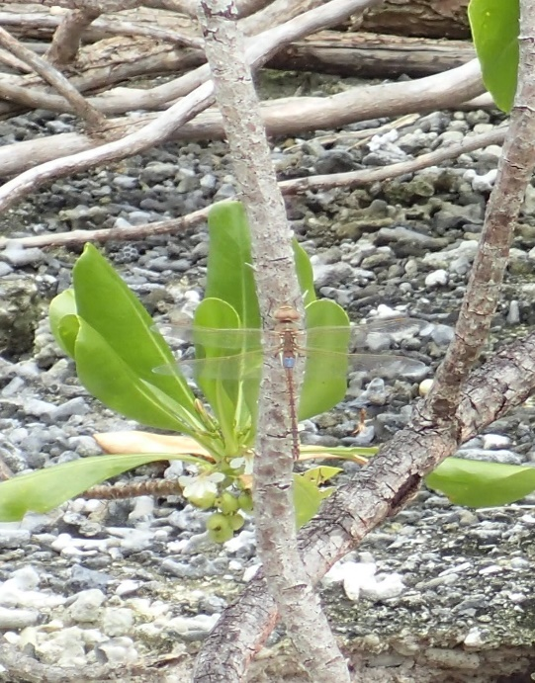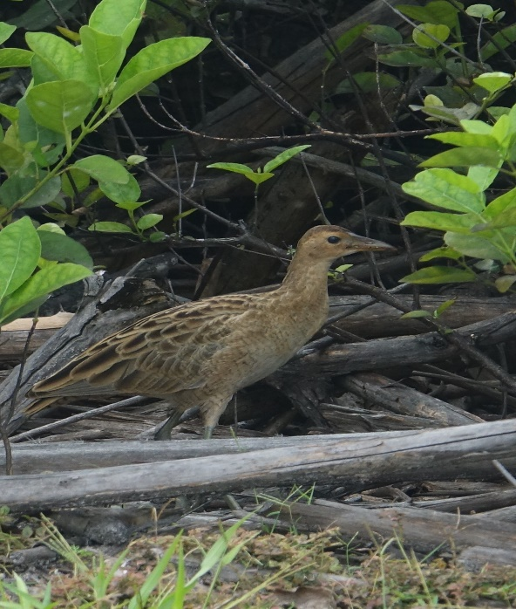

Figure 3. Vagrant Emperor Figure 4. Watercock

Opportunistic records of all taxon were gathered throughout the research activities. This resulted in a new species of bird and dragonfly to the Territory being discovered and photographed. The bird is a Watercock *Gallicrex cinerea* and the dragonfly is Vagrant Emperor *Hemianax ephippiger*. Other observations of interest were second records ever of Oriental Plover *Charadrius veredus*, Black-winged Stilt *Himantopus himantopus* and Intermediate Egret *Ardea intermedia* alongside other sightings of rarities such as Amur *Falco amurensis* and Peregrine Falcon *Falco peregrinus*. All of these records will be published in appropriate journals in 2018.

Indian Ocean Coastal Waterbird Count (IOCWC) 2018

Throughout the research data was collected for inclusion in the international collaboration of the IOCWC (see <https://www.osme.org/content/can-you-help-surveys-indian-ocean-coast> for details). This is the first time ever BIOT has partaken in this visionary ocean basin-wide survey. PC will submit the collected data to the IOCWC within three months.

Equipment Trials

The trial of an Istahub Isavi Inmarsat communication system was unsuccessful due to the equipment being faulty. This has been returned to the manufacturer and renewed. Trials of the replacement unit post fieldwork have proven it works as expected. It is planned to have the replacement unit trialled in BIOT by other visiting researchers prior to the proposed fieldwork in June/July 2018 on DG and Nelson’s Island.

The XO, Maj. Adams laid on an excellent demonstration of military equipment that visiting scientists conducting terrestrial research could consider using. It was agreed that the military sleeping systems were far superior to those being used by the research team and, if allowed, would be rented for the duration of fieldwork in the Territory in the future.

**Conclusion:** The January 2018 seabird research visit was an outstanding success, achieving all of its primary objectives and all bar one of the secondary objectives. Those secondary objective not met was due to faulty equipment and was not mission critical. Discovering two new species for the Territory was an unexpected bonus. Success was achieved through thorough planning, good communication with BIOTA prior to the visit and outstanding support for the duration of the research. All of the seabird team wish to extend their sincere gratitude to all concerned who made the visit such a success.

**Acknowledgements:** The fieldwork was funded by the Bertarelli Programme of Marine Science. The research would not have been possible without the full support of the BIOTA and, on Diego Garcia, particularly Maj. Martyn Adams RM the Executive Officer at the time of the visit. Several of the BF BIOT personnel extended assistance well beyond what was asked; particular gratitude is extended to Mary-Grace Dumlao for her administrative work; Cpl. Andrew Boagey RM and the Royal Marine Landing Craft Detachment and Cpl. Gareth Thomas MC RM for logistical support. All of the volunteers who committed to the project are sincerely thanked for their time, enthusiasm and company. Finally, the Environmental Officer Harri Morrall is owed a deep debt of gratitude for her advice, company and outstanding support prior to and throughout the visit.